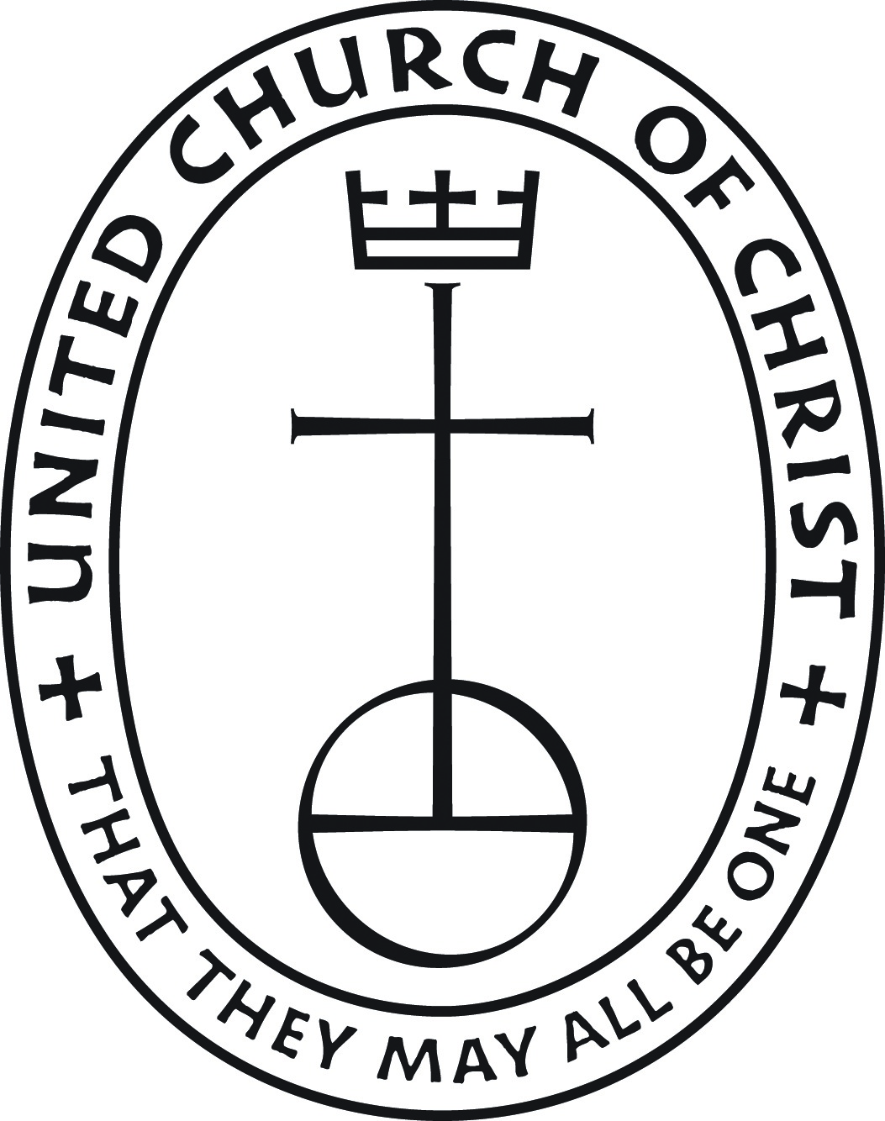 258 South Columbus Avenue
Mount Vernon, New York, 10553
Tel.: 914-668-7987
Website: www.mtvernonheightscc.org
Baby Dedication Request Form

You And Your Baby’s Dedication
“Behold, children are a heritage from the Lord, the fruit of the womb is a reward.” Psalm 127:3

We have the tremendous responsibility given to us when the Lord blesses us with a child. By doing so he entrusts us with responsibility of raising up that child in the way of the Lord and establishing early in his/her life a foundation built upon Jesus Christ.

The sacrament of baptism is an outward and visible sign of the grace of God. In as much as the promise of the gospel is not only to us but also to our children, baptism with water and the Holy Spirit is the mark of their acceptance into the care of Christ’s church, the sign and seal of their participation in God’s forgiveness, and the beginning of their growth into full Christian faith and discipleship.

We would like you to answer a few brief questions that will be used to assist us in preparing for you and your child for dedication.

PARENTS’ INFORMATION

Mother’s Name:

(Last Name) (First Name)

Father’s Name:

(Last Name) (First Name)

Address:

Date of Dedication: Phone: Email:

BABY’S INFORMATION

Name:
(Last Name) (First Name) (Middle)

Date of Birth: Hospital: □ Male □ Female

CHURCH INFORMATION
Are you a member of the Mount Vernon Heights Congregational church? □Yes □No Are you married? □Yes □No
Are you a born again Christian? □Yes □No

Godparents: 1. ___________________________________ 2. __________________________________

3. ___________________________________ 4. __________________________________

